**2 Overall Descriptions**

**2.1 Product**

The mobile app will provide a "one stop shop" style of app that will provide the users with information and support to caregivers. The client wants the application to be able provide everything that is needed for the user, from a tracker for the child, to hospital helplines, to tutorials for child care including documentation and videos.

Health Hearts at Home will provide an essential tool for the parents and caregivers, and will be informed by the Hospital on the benefits and uses of the app.

The app will be first developed for iOS, with the intent of being ported to android later in development. As well as provide an English and Spanish version of the app.

**2.1.1 System Interface**

The application's first development will be built using XCode. The mobile app will have several pages that will pull from a database. From the database, documentation and videos for tutorials/information, maps and contact information of the hospital, will be pulled.

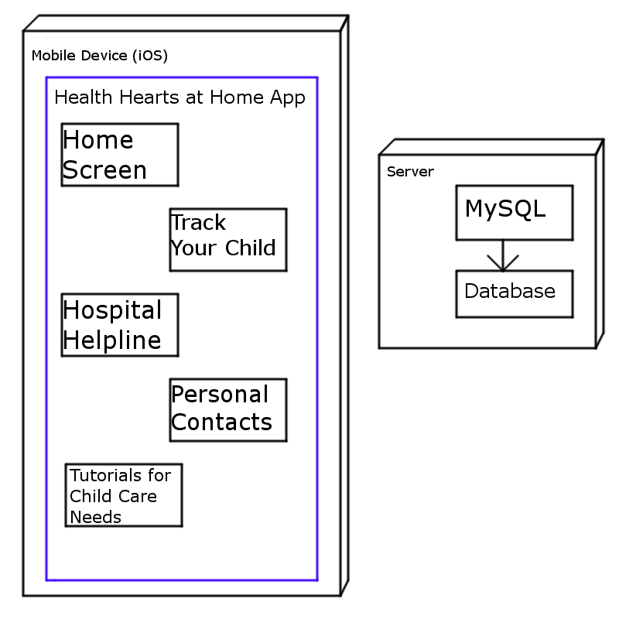

**2.1.2 User Interface**

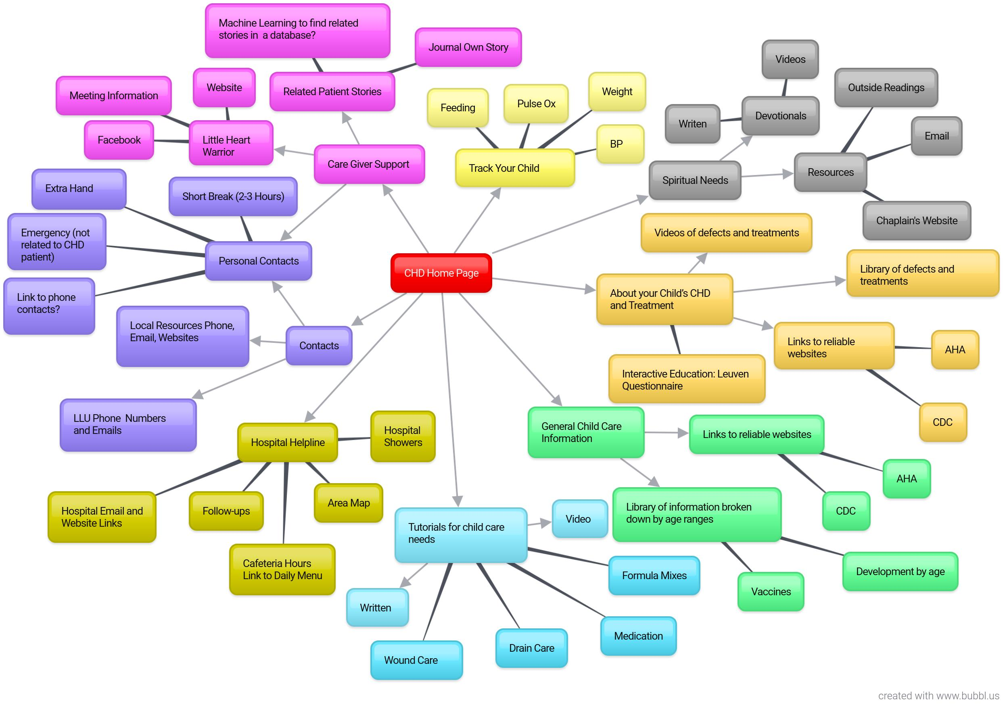

Interface:

This is the detailed version of the user interface, as the goal for the final product. The user will load into the home screen and will see 8 main options that can load into multiple other screens. The options will be provided in a list displayed on the home screen. To transverse back to previous screens, there will be a back arrow on the top left.

**2.1.3 Software**

* XCode – for the iOS version
* Android Studio – for the Android version
* Photoshop
* Server set up by the CSUSB Team

**2.1.4 Memory**

The mobile will not be memory intensive, as all the documentation and videos for the tutorials will be kept on the database. While the tracking information for the child, entered by the user, will be saved to the phone.

**2.1.5 Run-Time**

When the app is downloaded, the app will only be running during the time of active use by the user.

**2.2 User/Admin Functions**

